Water Water Everywhere
Super Fab Science Lab

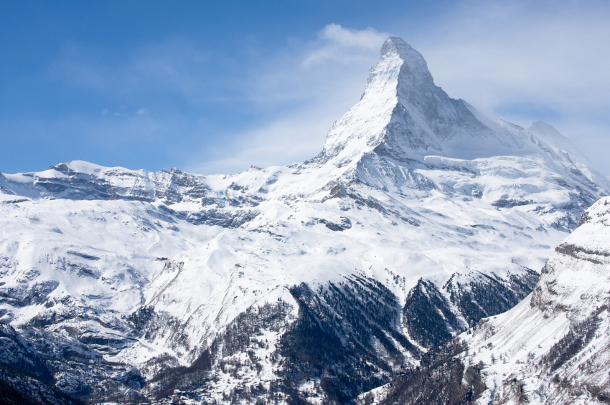
TIPS | TIP sources
Tip 9 -Insert image from internet | http://thornscompose.com/2010/03/02/bono-on-the-psalms/
Tip 8 - Inserted a pic of green hands with earth and added a beveled edge | Word Clip-art
Tip 7 - Inserted a WordArt that says Super Fab Science Lab | WordArt
Tip 6 – I inserted a star shape and add Water, Water Everywhere | Word
Tip 4 – Using extras, I selected styles to change the background of my collage | Word
Tip 3 – Table of tips | Word
Tip 2 – Swiss Alps | Downloaded and copied from Office Microsoft Clipart
Tip 1 – Labor Day | Searched and copied a pic from google.com, then copy and pasted

